**Q. Execute all the join with examples.**

Ans.

In MySQL, there are different types of joins that allow you to combine rows from two or more tables based on a related column. The common types of joins are:

**INNER JOIN :**

An INNER JOIN in SQL is used to combine rows from two or more tables based on a related column between them. The result set of an INNER JOIN only includes the rows from both tables that satisfy the specified join condition.

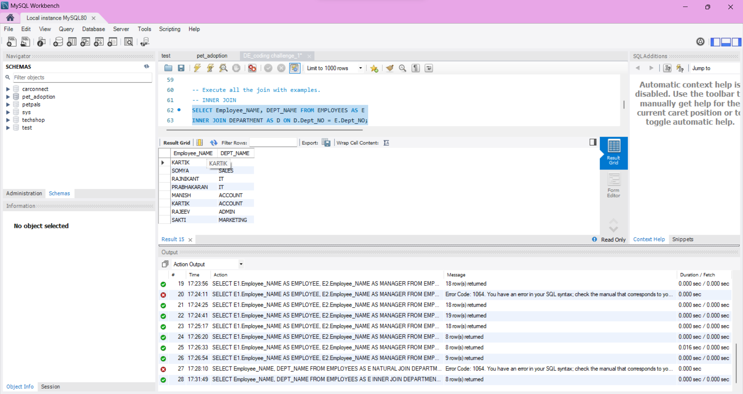

**LEFT JOIN** :

LEFT JOIN returns all rows from the left table and the matching rows from the right table. If there is no match, NULL values are returned for columns from the right table.

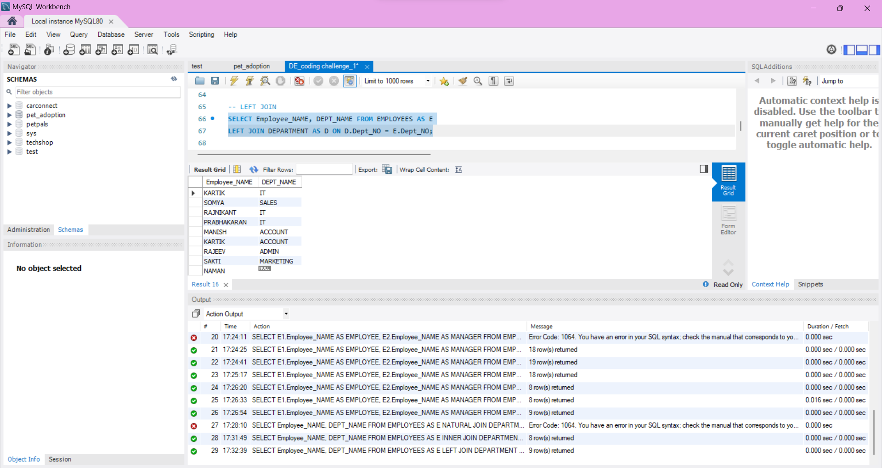

**RIGHT JOIN :**

RIGHT JOIN returns all rows from the right table and the matching rows from the left table. If there is no match, NULL values are returned for columns from the left table.

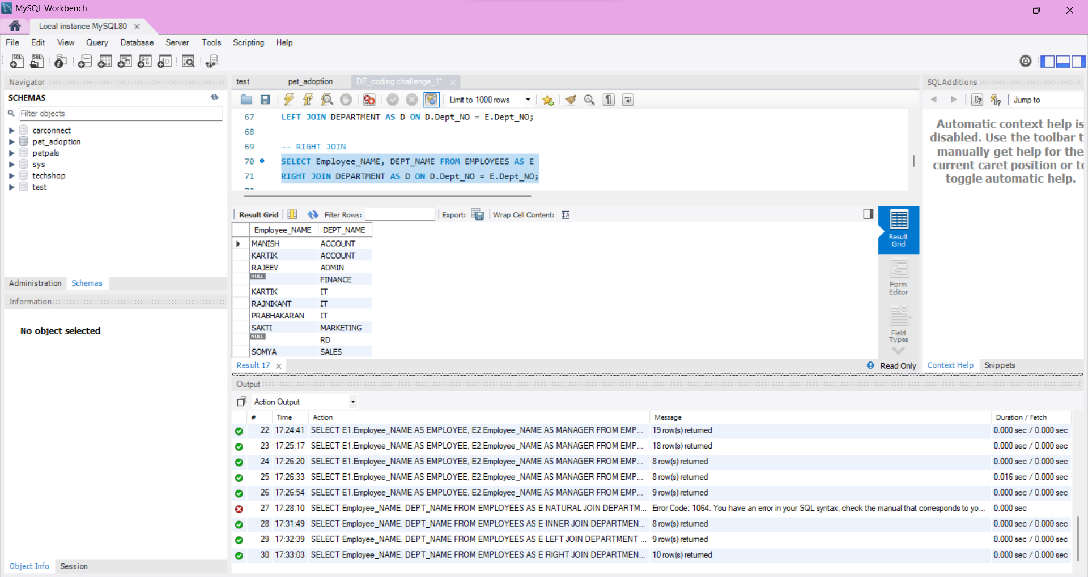

**FULL JOIN :**

Returns all rows when there is a match in either the left or the right table. If there is no match, NULL values are returned for columns from the table without a match.

Note: In MySQL, you can use a combination of LEFT JOIN and UNION to achieve a similar result as FULL JOIN.

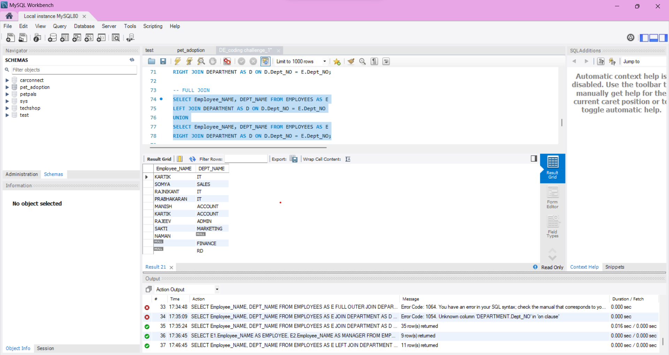

**CROSS JOIN :**

Returns the Cartesian product of the two tables, meaning it combines every row from the first table with every row from the second table.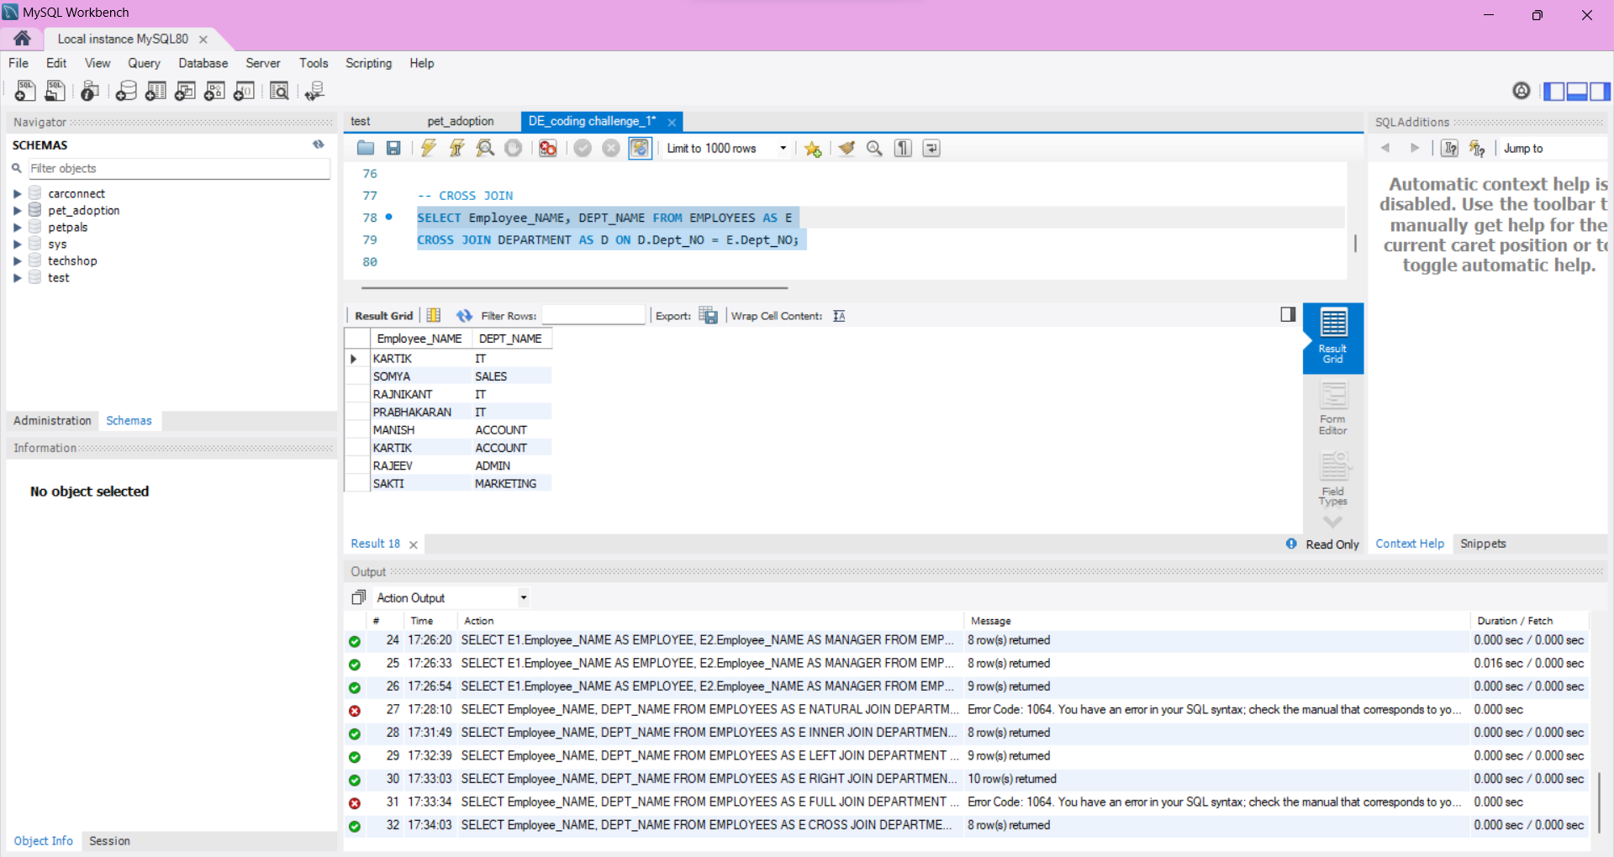

**NON-EQUI JOIN:**

A non-equijoin, also known as a non-equality join, is a type of join operation in SQL where the join condition does not use the equality operator (=) to match rows between tables. Instead, other comparison operators such as <, >, <=, >=, or non-equality operators like <> (not equal) are used.

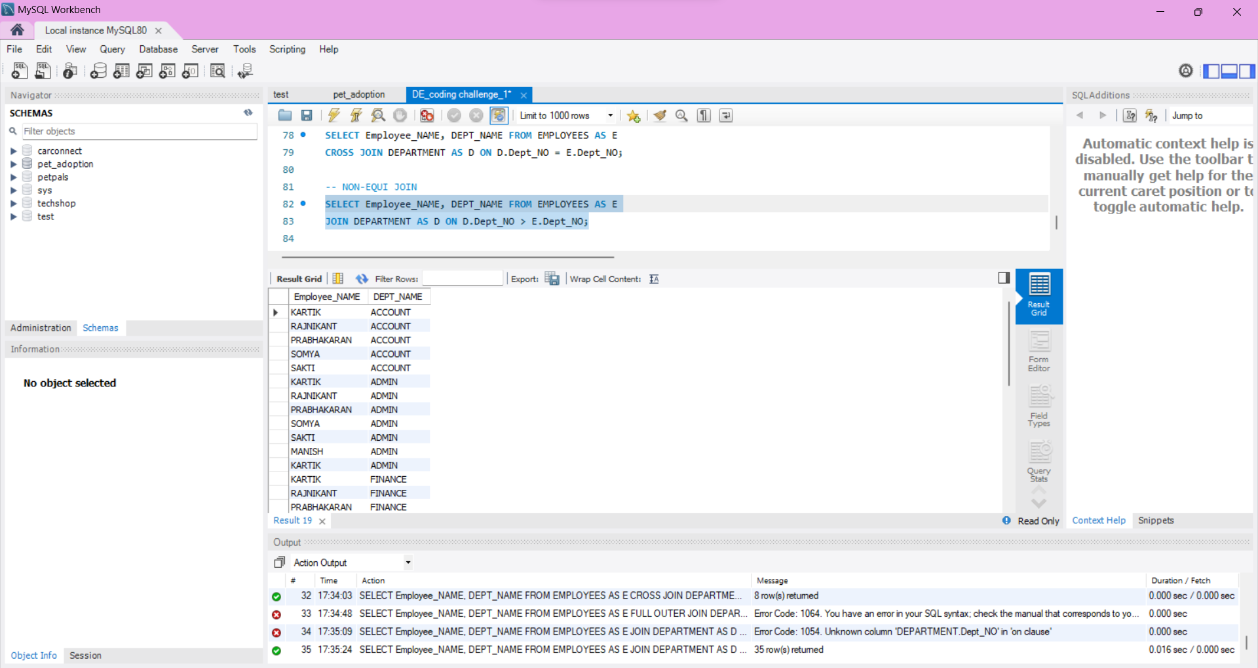

**SELF JOIN** :

A self join in SQL occurs when a table is joined with itself. This can be useful when you have a relationship within a table and you need to compare rows within that same table. A self join is typically performed using an alias to distinguish between the two instances of the same table.

